Preyasi Gaur

705704939

Stats 10

Homework 5

1. We are given that the average length of a baby follows an approximately normal standard distribution with μ = 19.2 inches and σ = 0.7 inches

a. x = 18 inches  
 z = $\frac{18 - 19.2}{0.7} = -1.71$

P(x < 18) = P(z < -1.71)  
 = 0.0436

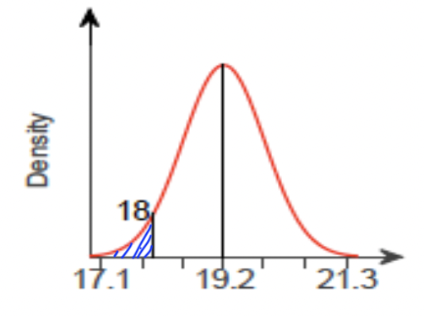

b. x = 20 inches  
 z = $\frac{20 - 19.2}{0.7} = 1.14$

P(x > 20) = P(z > 1.14)  
 = 1 - P(z ≤ 1.14)

= 1 - 0.8729

= 0.1271

Thus, 12.71% of the babies are longer than 20 inches  
 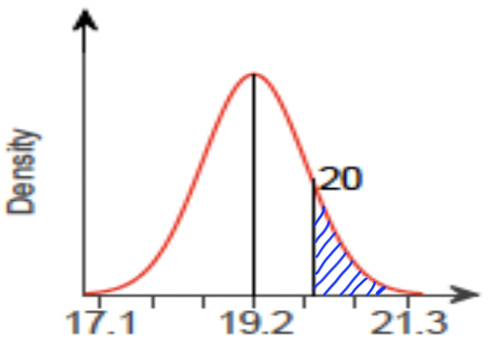

c. x = 18 , z = - 1.71

x = 20.4, z = $\frac{20.4 - 19.2}{0.7} = 1.71$  
 P(18 < x < 20.4) = P(-1.71 < z < 1.71)

= P (-1.71 < z < 0) + P(0 < z < 1.71)

= 0.4564 + 0.4564

= 0.9128

Thus, (1 - p) = 1 - 0.9128 = 0.0872

Thus, we see that 8.72% of the babies will not fit into the “newborn” size.   
 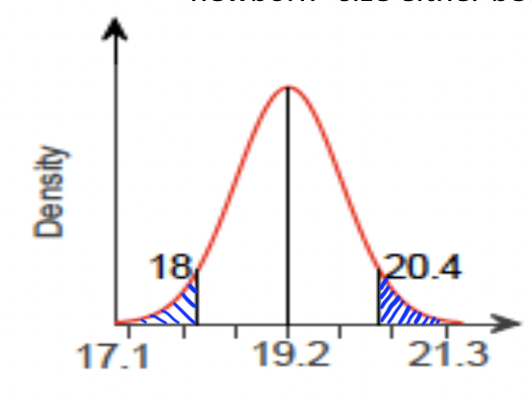

1. We know that the score of this exam follows a normal distribution N(400, 60).

Thus, μ = 400 and σ = 60  
  
If the school admits students who score only in the top 30% then,

P(Z ≥ z) = 0.30

1 - P(Z ≤ z) = 0.70

Thus, looking at the probability density table, we get

z = 0.524

Now, we know

$\frac{x - μ}{σ} = z$

$\frac{x - 400}{60} = 0.524$

$x = 0.524*60 +400$

$x = 431.44$

Thus, we have calculated that the top 30% of the scorers score 431.44 marks or more. Therefore, a student who scores 428 on the test is not in the top 30% and will not be admitted.

1. a. Verifying the Central Limit Theorem conditions we see:   
   • Random and Independent: The sample of 800 adults is clearly stated to be random and the observations are independent  
   • Large Sample: Notice that in this case, n = 800 and p = 0.82. This implies that

$(1-p) = 1-0.82 = 0.18$,

$np = 800*0.82 = 656 >10$

$n(1-p)=800*0.18=144>10$

Thus the sample is large enough.

• Big Population: Here, the population of the country (N) is more than 10n, where n = sample size = 800. $N>10n$ 
 => N > 8000

Thus the conditions of the Central Limit Theorem are verified.

b.   
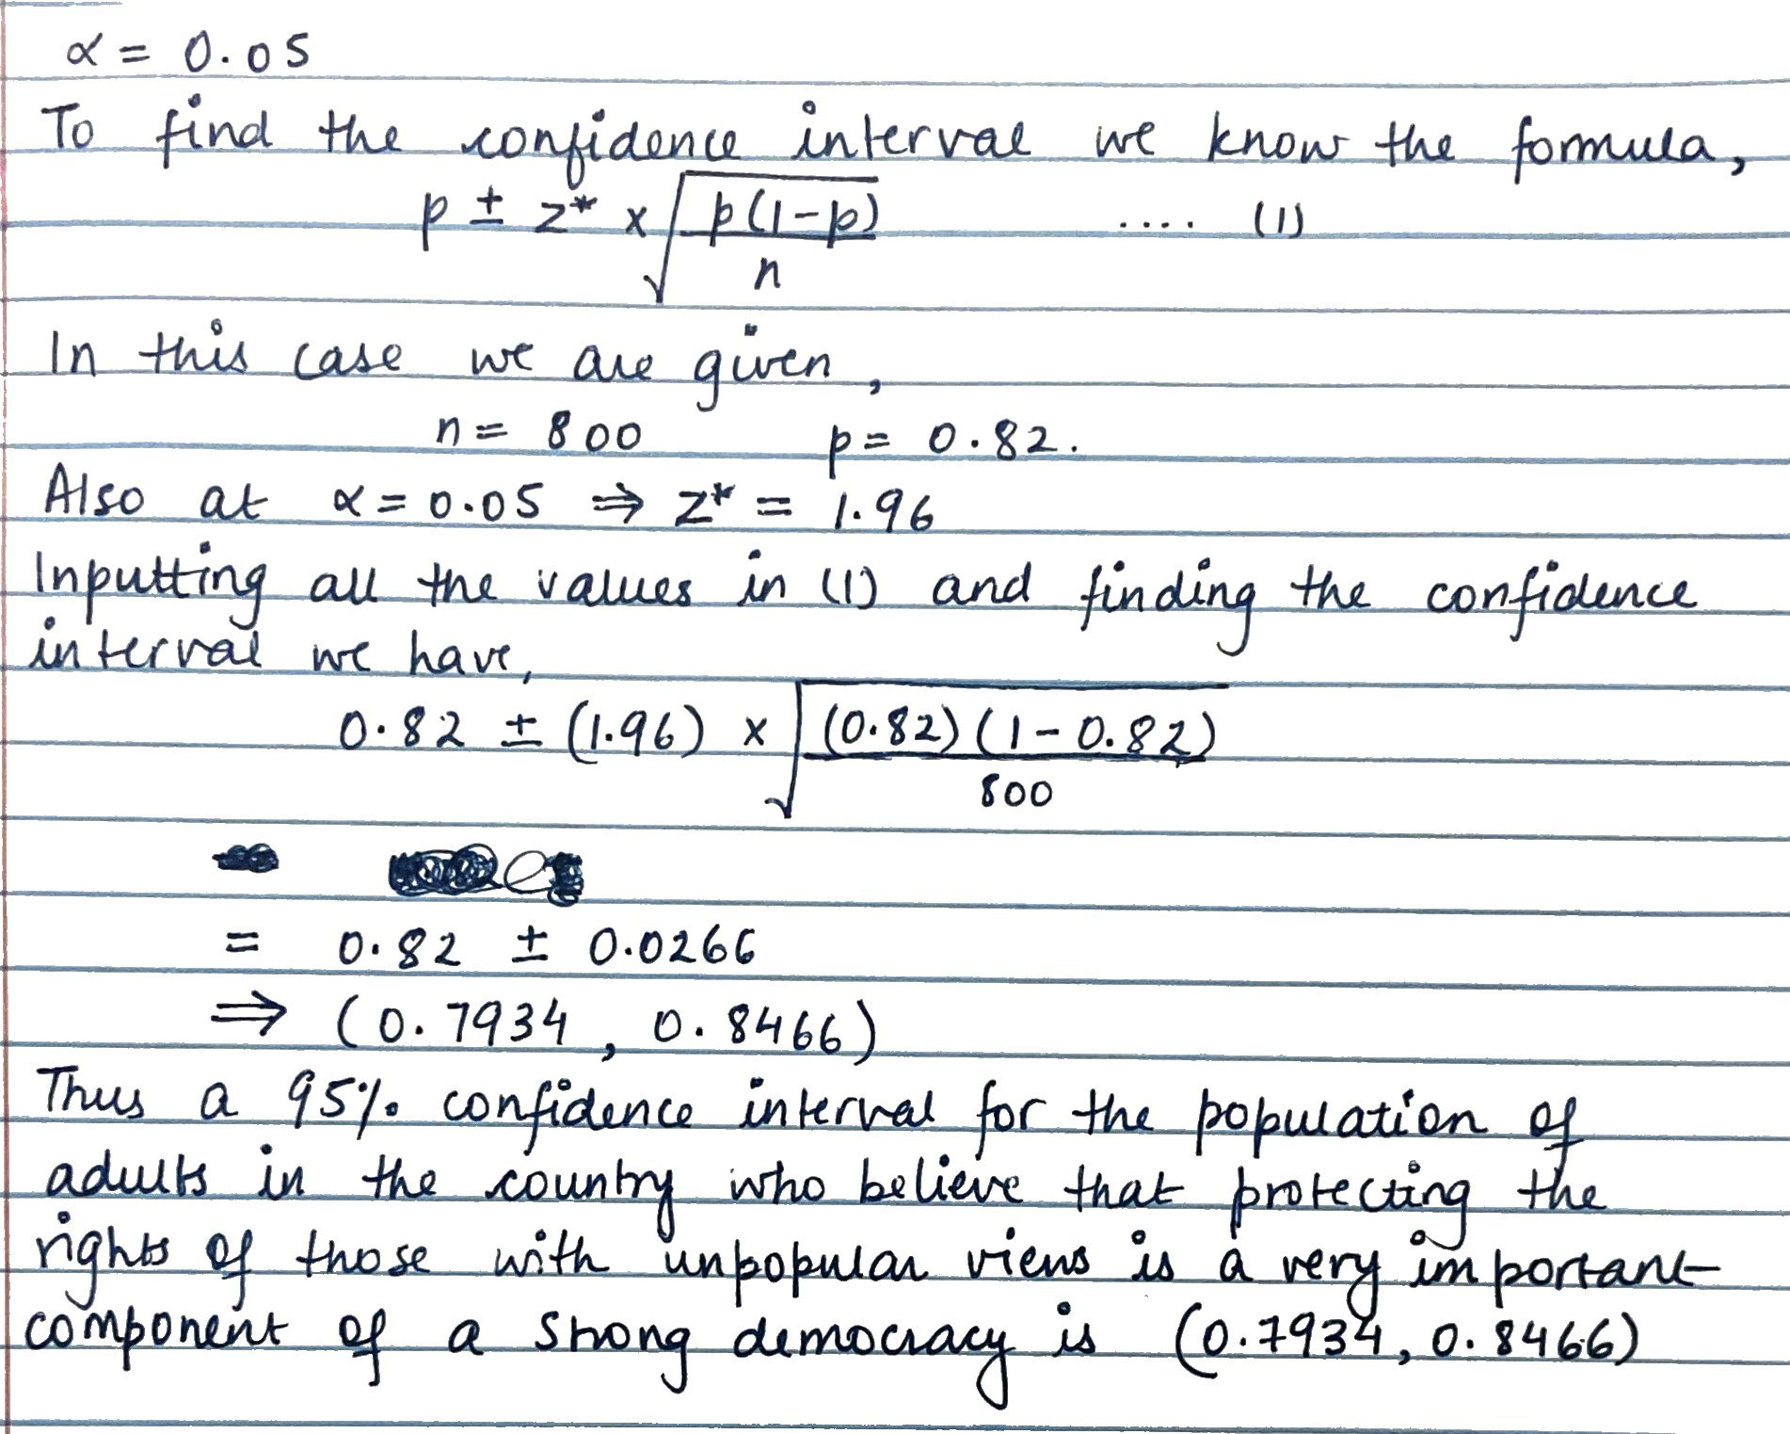

c. Here the sample size (n = 800) is constant, and thus a 90% confidence interval would be narrower than a 95% confidence interval. This is because the 90% interval is less likely to contain the population parameter.

1. a. The claim is that the population of site users who get their world news on this site has changed since 2013 so the null and alternate hypothesis are:  
    Null hypothesis: $H_{0}: p=0.48$  
    Alternate hypothesis: $H_{a}: p ≠ 0.48$  
   This is a two-tailed hypothesis.

b. We have   
 Number of sample (n) = 3625

Number of favorable cases (X) = 1830

Sample proportion ($p_{a}$) = $\frac{X}{n} = \frac{1830}{3625}=0.5048$

Now verifying the data with CLT conditions:

• Random and Independent: The sample is random and the observations are independent (stated)

• Large Sample: Notice that in this case $(1-p_{a}) = 1-0.5048 = 0.4952$ 
 ,

$np_{a} = 3625*0.5048 = 1830 >10$

$n(1-p_{a})=3625*0.4952=1795>10$

Thus the sample is large enough.

• Big Population: Here, the number of social media users on the site (N) is more than 10n, $N>10n$  
 => N > 36250  
Thus, the conditions of CLT are verified.   
The test statistics:   
 Sample Size (n) = 3625

Favorable Outcomes (X) = 1830  
 Sample proportion ($p_{a}$) = $\frac{X}{n} = \frac{1830}{3625}=0.5048$  
 z test statistic = $\frac{p_{a }-{ p_{0}}_{}}{\sqrt{\frac{{ p_{0}}_{}(1-{ p_{0}}_{})}{n}}}$ = $\frac{0.5048 -{ 0.48}_{}}{\sqrt{\frac{0.48 (1-{ 0.48}_{})}{3625}}} = 2.99$  
  
c. Since the alternate hypothesis is two tailed, we can calculate the p-value as,

p-value = 2 P( Z ≥ | z |)

= 2 \* 0.0014

= 0.0028 < 0.05

d. The p-value is statistically significant as the p-value is less that the significance level of 0.05, so we can reject the null hypothesis ${ H_{0}}_{}$. Thus, we can conclude that the proportion of site users who get their world news on this site has changed since 2013.